|  |
| --- |
|  |
| Term Project |
|  |



**Structural Engineering & Structural Mechanics**

**CVEN 5525 – Intermediate Structural Analysis**

Franco Sola

December 12th, 2017

Contents

Table of Figures 2

Introduction 3

2-D Frame Element 3

Example 6.7 Results: 3

Grid Element 4

Example 8.2 Results: 4

3-D Frame Element 5

Example 8.4 Results: 5

Geometric Non-Linearity 6

GNL Results 6

Stability 7

Program Results 7

Iterative Analysis 8

Parametric Study 8

Iterative Analysis and Results: 8

Column’s Parameters 25% 9

Column’s Parameters 50% 9

Column’s Parameters 100% 10

Column’s Parameters 150% 11

Column’s Parameters 200% 12

Discussion 13

Conclusion 14

# Table of Figures

Figure 1 Example 6.7 Deformed Shape……………………………………………………………………………………………………3

Figure 2 Example 8.4 Deformed Shape……………………………………………………………………………………………………5

Table 1 Beam & Column Initial Parameters……………………..……………………………………………………………………..7

Figure 3 Deformed Shape Column Parameters 25%………………………………………………………………………………..8

Figure 4 Deformed Shape Column Parameters 50%………………………………………………………………………………..9

Figure 5 Deformed Shape Column Parameters 100%…………………………………………………………………………….10

Figure 6 Deformed Shape Column Parameters 150%……………………………………………………………………………11

Figure 7 Deformed Shape Column Parameters 200%…………………………………………………………………………….12

Figure 8 Beam & Column Stresses…………………………………………………………………………………………………………13

# Introduction

The direct stiffness method is a powerful tool within structural analysis. It allows for analysis of indeterminant structures with an arbitrary number of degrees of freedoms. This project aims to create a Matlab program that is capable of analyzing such structures. Although Stiffness Matrix analysis is rather elementary, appropriate implementation requires proper forethought in order to account for arbitrary structural combinations (2-D Frame, Grid, 3-D Frame, etc.). The Matlab program can fulfill its purpose robustly and accurately.

# 2-D Frame Element

Validation of 2-D Frame performance was achieved utilizing example 6.7 provided in the Term Project file. The program’s result, available below, matched perfectly with the ones derived in the example problem. Furthermore, two more frame problems were tested (problem from p-code folder and prior HW problem) and results for both problems matched exactly.

## Example 6.7 Results:

Displacements:

(Node: 3 delta X) 1.854237e-01

(Node: 3 delta Y) 4.187389e-04

(Node: 3 rotate ) -1.761987e-02

(Node: 4 delta X) 1.855214e-01

(Node: 4 delta Y) -1.307389e-04

(Node: 4 rotate ) -2.602848e-02

(Node: 5 delta X) 1.866234e-01

(Node: 5 delta Y) 7.136699e-04

(Node: 5 rotate ) 1.789120e-02

Reactions:

(Node: 1 Fx) -1.060512e+02

(Node: 1 Fy) -1.570271e+02

(Node: 1 M ) 3.604414e+02

(Node: 2 Fx) -8.594878e+01

(Node: 2 Fy) 4.902711e+01

(Node: 2 M ) 3.203147e+02

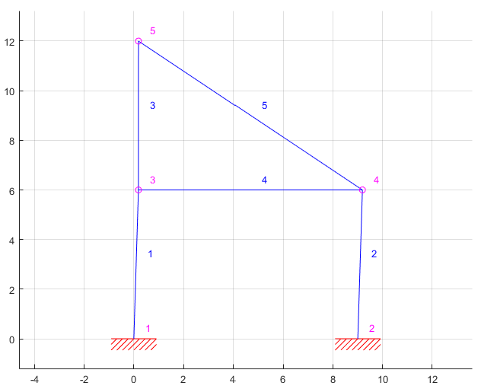

Figure 1 Example 6.7 Deformed Shape

# Grid Element

The program was expanded to accommodate for analysis of grid structures. Grid structures are very similar to 2D-frames, however, they experience torsion instead of axial forces. Therefore, the element stiffness matrix was updated to account for two moments (along X and Y axis) and a shear component (along Y-axis). Furthermore, the rotational matrix was updated to account for rotations about the Y-axis as this is the case in grid structures. Example 8.2 below was used to validate results

## Example 8.2 Results:

Displacements:

(Node: 4 rotate X) 1.133027e-02

(Node: 4 delta Y) -5.595093e-02

(Node: 4 rotate Z) -5.485621e-03

Reactions:

(Node: 1 Mx) -5.066168e+01

(Node: 1 Fy) 1.468566e-02

(Node: 1 Mz ) 5.913979e+01

(Node: 2 Mx) -4.450588e+02

(Node: 2 Fy) 1.446685e+02

(Node: 2 Mz ) 7.990721e+00

(Node: 2 Mx) -1.237832e+01

(Node: 3 Fy) 1.353169e+02

(Node: 3 Mz ) 3.755219e+02

# 3-D Frame Element

The program was also expanded to analyze 3D frame elements. These are the most “complete” elements as they experience axial, shear in Y and Z and moments along X, Y and Z. This means that the program will be able to analyze any type of structures with an arbitrary amount of degrees of freedoms. Updates to the element stiffness matrix was necessary to account for the additional 3 DOFs at each node which resulted in a 12 by 12 element stiffness matrix. The rotational matrix was updated to account for rotations about the Y axis, Z axis and X axis, the latter to ensure the bending axis of the element is correctly captured (I.E. I beams). Forces can be applied at a point or along an element in the X, Y and Z direction. Example 8.4 was used to corroborate the results.

## Example 8.4 Results:

Displacements:

(Node: 1 delta X) -1.352245e-03

(Node: 1 delta Y) -2.796532e-03

(Node: 1 delta Z) -1.811980e-03

(Node: 1 rotate x) -3.002109e-03

(Node: 1 rotate y) 1.056911e-03

(Node: 1 rotate z) 6.498580e-03

Reactions:

(Node: 2 Fx) 5.375736e+00

(Node: 2 Fy) 4.410629e+01

(Node: 2 Fz) -7.427245e-01

(Node: 2 Mx) 2.172151e+00

(Node: 2 My) 5.898736e+01

(Node: 2 Mz) 2.330520e+03

(Node: 3 Fx) -4.624913e+00

(Node: 3 Fy) 1.111738e+01

(Node: 3 Fz) -6.460652e+00

(Node: 3 Mx) -5.155458e+02

(Node: 3 My) -7.647191e-01

(Node: 3 Mz) 3.696717e+02

(Node: 3 Fx) -7.508236e-01

(Node: 4 Fy) 4.776328e+00

(Node: 4 Fz) 7.203377e+00

(Node: 4 Mx) -3.835015e+02

(Node: 4 My) -6.016643e+01

(Node: 4 Mz) -4.701994e+00

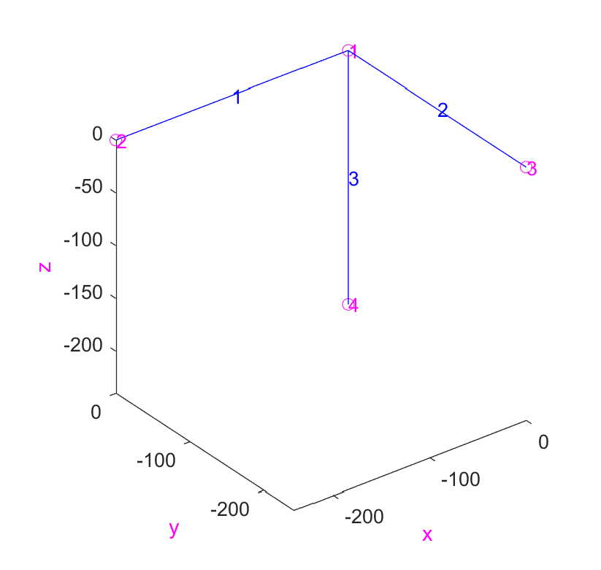

Figure 2 Example 8.4 Deformed Shape

# Geometric Non-Linearity

To account for large displacements in 2-D frames, a geometric stiffness module was updated. This module calculates the geometric stiffness matrix **Kg** for each element by updating the elements coordinates, length and rotational matrix after the initial analysis to provide information necessary for the calculation of **Kg**. If GNL is selected (GNL=1 and Stability=0 in input file), the geometric stiffness matrix is added to the augmented stiffness matrix through its respective module. An iterative process that depends on the norm of the displacement and takes place in the main program (casap) ensures convergence. This type of analysis is able to provide more exact results as it takes into account potential non-linear behavior experienced by the structure.

## GNL Results

The results achieved for the test_geom_nonl file provided matched exactly to the example output. As seen below, after 14 iterations, the program converged to the correct response

Number of Iteration : 14

Displacements:

(Node: 2 delta X) 7.775509e-18

(Node: 2 delta Y) -8.037706e-01

(Node: 2 rotate ) -1.958551e-18

Reactions:

(Node: 1 Fx) 4.363098e+03

(Node: 1 Fy) 2.500000e+03

(Node: 1 M ) 5.798311e+03

(Node: 3 Fx) -4.363098e+03

(Node: 3 Fy) 2.500000e+03

(Node: 3 M ) -5.798311e+03

# Stability

Stability analysis is a crucial aspect of preliminary design, as it gives an idea of buckling loads for the structure. Due to the implementation of Geometric Nonlinear Analysis, the program is able to calculate critical loads of the structure by solving |**Ke**+λ**Kg**|=0. Assuming P=1 in the input, λ will provide the critical loads for the system (I.E. the load that will cause buckling), the smallest load λcr is known as the buckling load.

This program is limited to linearized pre-buckling, meaning it is not able to provide information on the system after buckling, which its often desired to ensure stability after the structure has undergone buckling. However, columns normally experience stable bifurcation

The buckling load of a Fixed-Free column will be investigated to ensure the program is performing properly. The theoretical buckling load (Euler Load) for a column is as follows:

$$P_{cr}^{E}=-\frac{π^{2}EI}{L_{eff}}$$

For Fixed-Free Columns:

$$L_{eff}=2L$$

Take:

$$E=1$$

$$I=1$$

$$L=1$$

Then:

$$P_{cr}^{E}=-2.47$$

## Program Results

The program computes λcr using the following formula (Stability=1 and GNL=0 need to be selected in input file):

$$A=K_{e}^{-1}K_{g}$$

$$Az_{i}=μ_{i}z_{i}$$

Where:

$$μ_{i}=-1/λ_{i }$$

This problem is then easily solved by an eigenproblem solver (eig function in Matlab) and results in a critical load of:

$$λ_{cr }=-2.486$$

Percent Error:

$$Error=\frac{\left|2.47-2.486\right|}{2.47}*100=0.8\% error$$

If the number of elements is doubled, $λ_{cr }=-2.47$ which is the same as the theoretical critical load calculated prior.

## Iterative Analysis

An iterative analysis was performed in which **Kg** was kept at zero, but nodal coordinates were updated to capture buckling. An initial displacement in the X-direction of 0.001 was utilized so as to simulate an imperfection and drive the solution forward. Different loading combinations were tested and it was found that buckling occurred at the theorized $λ_{cr }=-2.47$. Albeit correct, this method proved much more tedious than solving the prior eigenproblem.

# Parametric Study

The parametric study completed investigates an important design philosophy, weak-beam strong-column. As the name suggest, it is important, especially in seismic areas, to design columns to be much stronger than beams. This will ensure that failure occurs in beams which reduces the chance of total collapse at the cost of increased probability of partial collapse (plastic hinge formation at the beam).

For this study, a 2-D frame bay was investigated. A lateral point load was applied to simulate seismic forces (this does paint a complete picture, since structural dynamics and ground motion are not accounted for), however, it falls within the limitations of the program. The bay specs are as follows:

Table 1 Beam & Column Initial Parameters

|  |  |
| --- | --- |
| **Height** | 12-ft |
| **Length** | 15-ft |
| **Young's Modulus** | 290000 ksi |
| **Area** | 30 in2 |
| **Moment of Inertia** | 750 in4 |
| **Lateral Load** | 1500 kips |
| **Distributed Load** | -200 kip/ft |

## Iterative Analysis and Results:

A geometric non-linear iterative analysis approach was used to perform this investigation. The area and moment of inertia of the column were multiplied by .25, .5, 1, 1.5 and 2 to change its relative stiffness when compared to the beam which’s parameters remained the same. Stresses developed in each element will be investigated to gain an understanding of this design philosophy and its goals. Geometric non-linearity will be used to account for large displacements and possible P-Δ effects.

### Column’s Parameters 25%

E = 290000*[1 1 1];

A = 30*[0.25 1 0.25];

Iz = 750*[0.25 1 0.25];

Displacements:

(Node: 3 delta X) 3.608774e+00

(Node: 3 delta Y) 1.209280e-01

(Node: 3 rotate ) 4.039794e-03

(Node: 4 delta X) 3.550540e+00

(Node: 4 delta Y) 1.944650e-02

(Node: 4 rotate ) -3.765389e-02

Reactions:

(Node: 1 Fx) -7.965627e+02

(Node: 1 Fy) -1.825232e+03

(Node: 1 M ) 5.920662e+04

(Node: 2 Fx) -7.034373e+02

(Node: 2 Fy) -1.174768e+03

(Node: 2 M ) 1.090742e+05

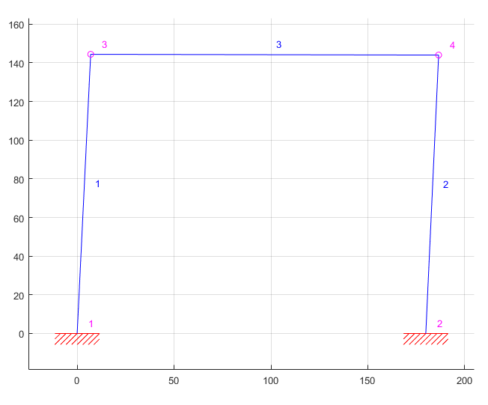

Figure 3 Deformed Shape Column Parameters 25%

### Column’s Parameters 50%

E = 290000*[1 1 1];

A = 30*[0.50 1 0.50];

Iz = 750*[0.50 1 0.50];

Displacements:

(Node: 3 delta X) 2.263929e+00

(Node: 3 delta Y) 6.406636e-02

(Node: 3 rotate ) 2.373424e-05

(Node: 4 delta X) 2.241320e+00

(Node: 4 delta Y) 1.763657e-02

(Node: 4 rotate ) -2.217011e-02

Reactions:

(Node: 1 Fx) -9.536866e+02

(Node: 1 Fy) -1.934573e+03

(Node: 1 M ) 7.083725e+04

(Node: 2 Fx) -5.463134e+02

(Node: 2 Fy) -1.065427e+03

(Node: 2 M ) 7.373091e+04

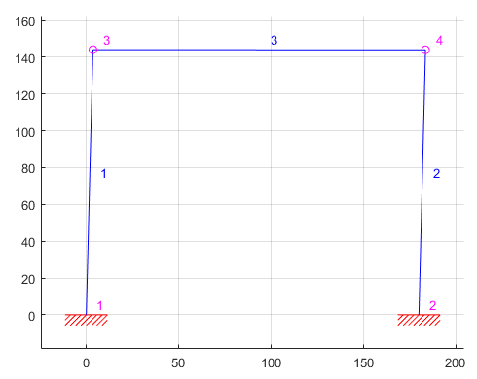

Figure 4 Deformed Shape Column Parameters 50%

### Column’s Parameters 100%

E = 290000*[1 1 1];

A = 30*[1 1 1];

Iz = 750*[1 1 1];

Displacements:

(Node: 3 delta X) 1.339345e+00

(Node: 3 delta Y) 3.319636e-02

(Node: 3 rotate ) -1.055464e-03

(Node: 4 delta X) 1.330698e+00

(Node: 4 delta Y) 1.646770e-02

(Node: 4 rotate ) -1.168497e-02

Reactions:

(Node: 1 Fx) -1.082109e+03

(Node: 1 Fy) -2.005184e+03

(Node: 1 M ) 8.082326e+04

(Node: 2 Fx) -4.178914e+02

(Node: 2 Fy) -9.948162e+02

(Node: 2 M ) 4.825967e+04

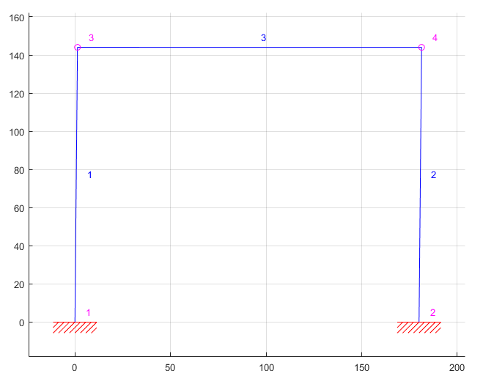

Figure 5 Deformed Shape Column Parameters 100%

### Column’s Parameters 150%

E = 290000*[1.5 1 1.5];

A = 30*[1.5 1 1.5];

Iz = 750*[1.5 1 1.5];

Displacements:

(Node: 3 delta X) 9.704502e-01

(Node: 3 delta Y) 2.239950e-02

(Node: 3 rotate ) -1.165220e-03

(Node: 4 delta X) 9.655702e-01

(Node: 4 delta Y) 1.606260e-02

(Node: 4 rotate ) -7.676841e-03

Reactions:

(Node: 1 Fx) -1.146208e+03

(Node: 1 Fy) -2.029656e+03

(Node: 1 M ) 8.612329e+04

(Node: 2 Fx) -3.537923e+02

(Node: 2 Fy) -9.703440e+02

(Node: 2 M ) 3.744731e+04

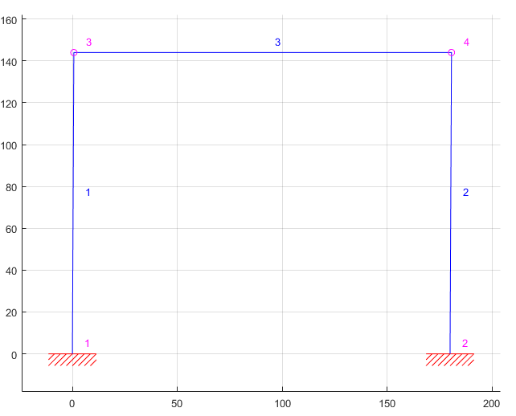

Figure 6 Deformed Shape Column Parameters 150%

### Column’s Parameters 200%

E = 290000*[2 1 2];

A = 30*[2 1 2];

Iz = 750*[2 1 2];

Displacements:

(Node: 3 delta X) 7.688922e-01

(Node: 3 delta Y) 1.689223e-02

(Node: 3 rotate ) -1.136425e-03

(Node: 4 delta X) 7.656673e-01

(Node: 4 delta Y) 1.587622e-02

(Node: 4 rotate ) -5.592249e-03

Reactions:

(Node: 1 Fx) -1.188268e+03

(Node: 1 Fy) -2.040915e+03

(Node: 1 M ) 8.974501e+04

(Node: 2 Fx) -3.117318e+02

(Node: 2 Fy) -9.590850e+02

(Node: 2 M ) 3.119410e+04

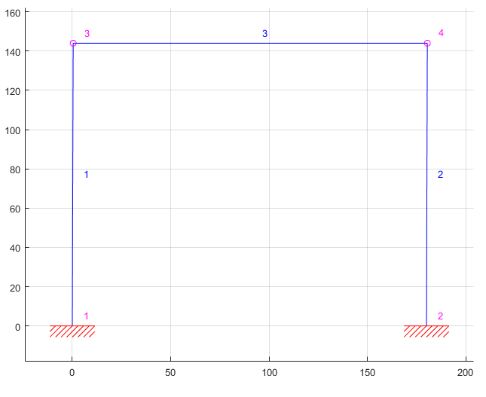

Figure 7 Deformed Shape Column Parameters 200%

## Discussion

Strong Column-Weak Beam aims to minimize major collapse by restricting catastrophic failure to beams instead of columns. To achieve this, columns are built stronger than beams attached to said column. The study shows that as the column’s relative stiffness increases when compared to the beam, the stresses developed reduce dramatically. Beam stresses increase slightly and eventually surpass column stresses, which indicate that if these two structural elements are composed of the same material, the beam will fail before columns does.

Although the study utilizes a highly simplified version of a seismic frame, it still helps to illustrate this theory that is imperative in seismic design. Overall, the Matlab program provided results that align with prevalent design theories.

Stresses were calculated by taking the largest internal moment induced by the element and diving by its moment of inertia (c was assumed to remain constant and equal in both columns and beams).

Figure 8 Beam & Column Stresses

# Conclusion

The program successfully utilized the direct stiffness method to analyze the aforementioned types of structures. It is not limited to number of degrees of freedoms, elements or force directions (I.E it is able to analyze applied forces in X, Y or Z direction in 3-D frames). Moreover, it is able to provide internal forces for each type of structure which can be used to calculate internal stressed, as was the case in the parametric study. This is a powerful tool as it can aid not only in analysis of a structure, but also in design.

Naturally, the program can handle metric and imperial units, however, it is important to remain constant with the units in the input file (I.E. use kips for force if Young’s Modulus is entered in ksi). The output will then reflect the units utilized in the program behaves robustly for each structural element and provides all information accurately and concisely. Further work was completed to ensure that the output file displays the correct force/moment and displacement/rotation direction. Geometric Non-Linearity can be toggled from the input file and allows the problem to account for large displacements and stability (I.E. buckling). Both features proved to converge to the correct results.